Weekly Status Report
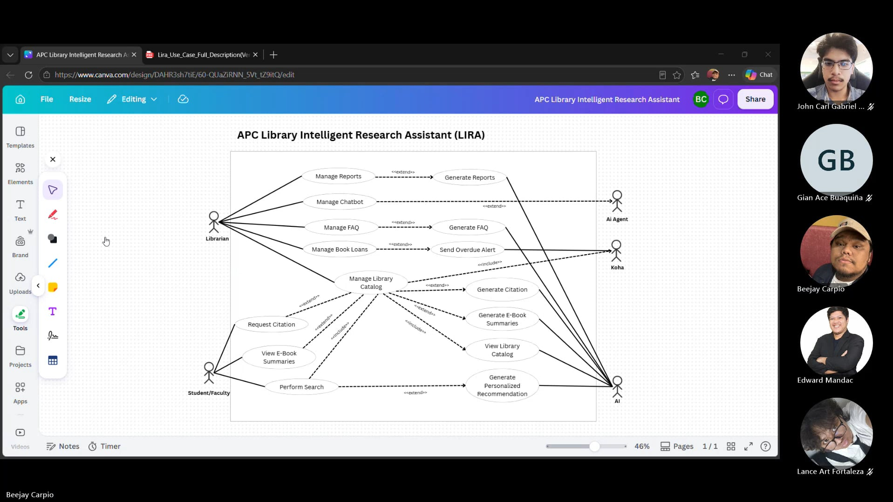
Minutes of Meeting
Date: 08-10-2026
Meeting Called By: Cache Flow
Facilitator: Edward Mandac
Link of the Meeting: Cache Flow - Weekly Status Meeting | Meeting Chat | Microsoft Teams

1. Attendees
Gian Ace Buaquiña
Beejay A. Carpio
Lance Art P. Fortaleza
John Carl Gabriel Guzman
2. Agenda
* What are the deliverables this week
- Revise and finalize the Use Case Diagram and Use Case Full Description
- Correct the Koha (external system) associations and extend relationships in the Use Case Diagram
- Produce the three lacking C4 diagrams: System Context, Container, and Component
- Draft and send the client's Minutes of Meeting (MOM) for review
3. Summary
* Status update for the week
- The team reviewed the Use Case Diagram and Use Case Full Description. It was identified that the Koha system was incorrectly shown as sending the overdue alert; this was corrected since Koha only stores catalog data and the overdue alert is a static, non-AI notification based on the current date and the book's due date.
- The extend relationship for Manage Chatbot was corrected. Since "extend" can only connect one use case to another (not a use case to an actor), Manage Chatbot now extends a new "Generate AI Response" use case, which in turn connects to the AI agent actor.
- It was clarified that not every use case needs an extending use case or a connection to the AI actor. Manage FAQ, for example, does not always require an extended use case, since some FAQs are answered directly by the librarian instead of being generated by AI.
- The Koha system will instead be connected with a solid association line directly to the Manage Library Catalog use case, since Koha stores and provides the catalog contents.
- The plan for the week is to finalize the Use Case Diagram and Use Case Full Description revisions, have them checked again by the adviser for safeguarding, and begin work on the three remaining C4 diagrams (System Context, Container, and Component). An initial draft is targeted for Thursday, with the goal of completing all three C4 diagrams by next Monday for review.

* Blockers/Obstacle that encounter this week
- There was no meeting entry last Thursday, so the team's output could not be reviewed right away; it was checked and approved shortly after so work could continue.
- The Use Case Diagram and its extend/association relationships still need final sign-off from the adviser before the team can move fully into the C4 diagrams.

